
Koneru Lakshmaiah Education Foundation
(Deemed to be University estd. u/s. 3 of the UGC Act, 1956)
Off-Campus: Bachupally-Gandimaisamma Road, Bowrampet, Hyderabad, Telangana - 500 043. Phone No: 7815926816, www.klh.edu.in

STUDENT CASE STUDY EXECUTION REPORT
Department | FED
Subject | DSA-2
Academic Year | 1-III Semester (2025-2026)
Faculty Name | Mohd. Razia Alangir Banu
Student Name | M.Geethika
Roll Number | 2520030485
Branch | CSE
Course Outcome | Apply Binary Search Trees (BST) and self-balancing AVL Trees to construct, insert, delete, and search hierarchical datasets, demonstrating correct rotation operations and O(log n) performance guarantees in real-world file indexing and dictionary scenarios.

Case Study Topic: EduGraph – Adaptive Learning & Course Recommendation Platform
Work Done Summary:
Implemented BST and AVL Trees to manage student and course data efficiently in the EduGraph platform. AVL rotations were used to maintain balanced trees and ensure fast searching, insertion, and deletion with O(log n) performance. This improved course indexing and student record management.
Implementation Details:
- Implemented BST for storing and searching student and course records.
- Used AVL Trees to maintain balanced hierarchical data structures.
- Performed insertion, deletion, and search operations efficiently.
- Applied AVL rotations (Left, Right, Left-Right, Right-Left) to avoid imbalance.
- Achieved O(log n) time complexity for faster data retrieval and indexing.

Result: Screenshots / Output
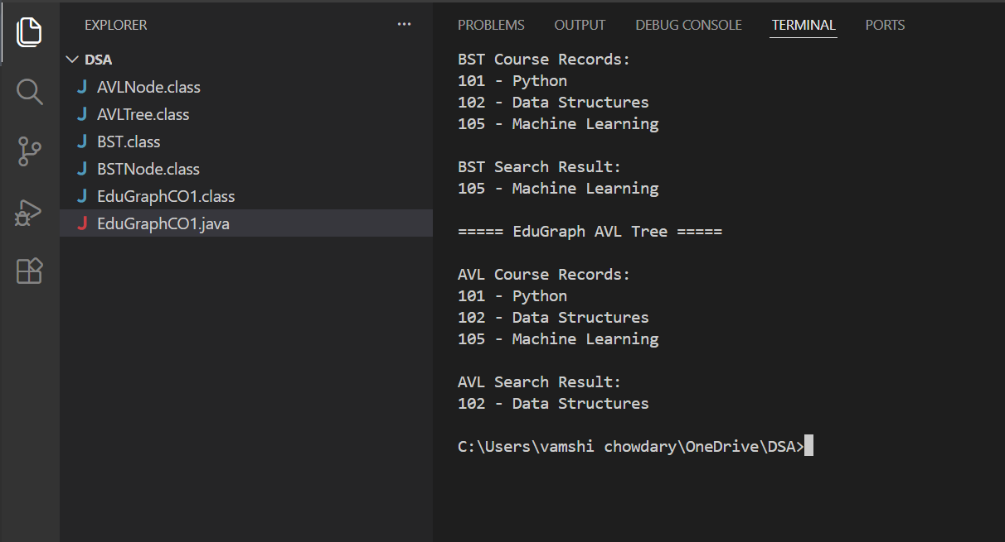

The program successfully implemented BST and AVL Trees for managing course records in the EduGraph platform. AVL Tree maintained balanced structure using rotations and provided efficient searching with O(log n) performance.
GitHub Link:

Student Signature: Faculty Signature:

